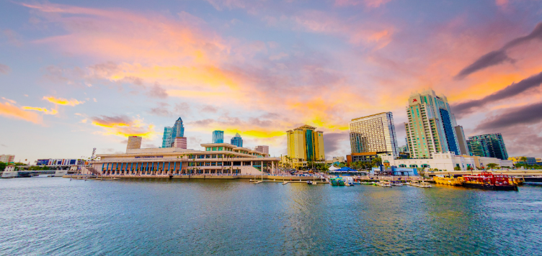
42nd Blanding Family Reunion
Tampa, Florida
“Our Roots Run Deep, Our Love Runs Deeper”
Friday, July 5, 2024- Sunday July 7, 2024

Dear Family,
The 2024 Blanding Family Reunion Committee is pleased to host the 42nd Blanding Family Reunion in Tampa, Florida! Tampa is a vibrant city, known for its rich history, diverse culture, and countless attractions.
We’ve planned an experience that will create unforgettable memories for our family as well as allow you an opportunity to explore our host city. We’ve chosen a hotel central to downtown Tampa near several attractions that are accessible by walking, water taxi, or the free streetcar trolley.
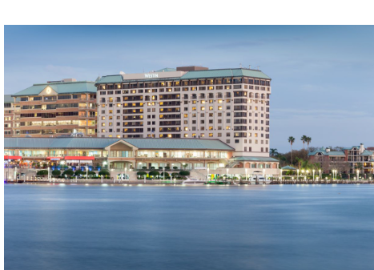
Hotel and Room Rates:
The Westin Tampa Waterside
725 South Harbour Island Boulevard
Tampa, FL 33602
813-229-5000
Rate: $159.00
You may begin making reservations on Feb.13th
The hotel is located on the waterfront near downtown attractions.

There are a limited number of rooms available for the 4th of July for those that may be arriving early.

Family Reunion Agenda

Thursday, July 4 (optional): On your own- suggestions below:
- Busch Gardens Fourth of July Celebration
- Downtown Fireworks Show

Friday, July 5: 3pm EST - Registration (The Westin Tampa Waterside)
Family Business Meeting (5:30pm)

Saturday, July 6: Tampa Bay History Center Tour (10am)
- Lunch
- Academic Achievement Spotlights
- Family Photo (Wear Reunion Shirt)

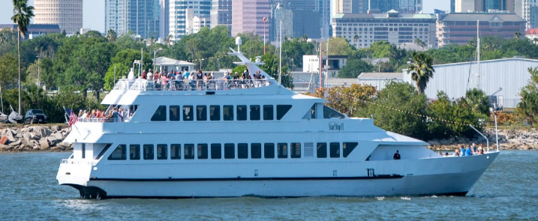
“Havana Nights” Yacht Dinner Cruise (4:30pm)

Wear your bright colored linen, sundresses, and
Panama jack hats and cruise the Tampa Bay!
*Boat is wheelchair accessible

Sunday, July 7: Church service
Travel home

“We are on the battle of love to serve God and help people at all times”

There are so many people that are in dire need of the bare necessities. As the Blanding Family, we never take for granted just how blessed we are. Our 42nd reunion will be our inaugural year to support and give back to the local community with a sock drive. We would like each family to bring a new package of solid black or white socks (adult or child sized) that will be given as a love offering to a local church that serves those in need.

Information To Remember

- We love all our cousins, but registration is due no later than May 31, 2024. The committee needs to ensure we have enough food, transportation, etc. for everyone and this is how we account for everyone attending.
- Registration forms can be emailed to Blandingfamilyreunion@gmail.com or mailed to the address below
Blanding Family Reunion
335 Chickering Lake Court
Roswell, GA 30075
- When booking your hotel room, please mention the Blanding Family Reunion.

Sincerely,
42nd Blanding Family Reunion Planning Committee
Michael and Michealla James (678-641-4279)
Renee Joseph (813-237-1652)
Osric and Kim Grant (678-699-9028)

Things to do in Tampa

During your free time, there are several things to do in Tampa!

Historic Rogers Park Golf Course Visit historic Ybor City
Busch Gardens Top Golf
Tampa Zoo Tampa Museum of Art
Hard Rock Casino Bowling at Splitsville
Visit Sparkman Wharf Bayshore Boulevard
Clearwater Beach

MY PAYMENT IS BY MAIL ___ 2024 Blanding Family Reunion
MY PAYMENT IS BY ZELLE ___ Tampa, FL
Friday, July 5th – Sunday, July 7th
REGISTRATION FORM
DEADLINE IS MAY 31, 2024

Name: _____________________________________________________
Address: _____________________________________________________
Phone: _____________________Email: ____________________________
FAMILY LINEAGE:
___ Leroy Blanding ___Anna Blanding ___Caleb Blanding ___Wash Blanding ___Howard Blanding
___ Pierce Blanding ___ Ornsby Blanding ___Jim Blanding ___Lucy Ann Blanding ___Not Sure
___ Lucy Blanding ___ Amelia Blanding ___Lad Blanding ___ Louise Blanding

List all family members who will attend
NAME | Adult (18+)  $200.00 | Youth  (11- 17)  $135.00 | Children  (5-10)  $50.00 | Infant/Toddler  (0-4)  FREE

NAME | Small  $13.00 | Medium  $13.00 | Large  $13.00 | X Large  $13.00 | 2X  $16.00 | 3X  $16.00
Adult T-Shirt Sizes

NAME | X- Small  $9.00 | Small  $9.00 | Medium  $9.00 | Large  $9.00
Children T-Shirt Sizes
Grand Total Due: _______
Mail-In Payments (Check/Money Order) & Registration to:
Kimberly Grant (Reunion)
335 Chickering Lake Court
Roswell, GA 30075

OTHER PAYMENT OPTIONS:
PayPal: Blandingfamilyreuion@gmail.com (via Friends & Family Options)
Zelle: 678-699-9028 (Please note your bank may have a limit on your daily outgoing transactions
Cash App: $blandingfamily

Voluntary Contributions for:
Scholarship Fund $___________
Benevolent Fund $___________
Website Support $___________
2024 BLANDING FAMILY REUNION
ACHIEVEMENT INFORMATION

The Tampa, Florida reunion committee would like to recognize the achievements of family members. If you or a family member would like to be recognized, please complete and return this form.

NAME ____________________________________________________________________
PARENTS (OPTIONAL) ______________________________________________________
HOMETOWN ______________________________________________________________
FAMILY AFFILIATION (LINEAGE) ____________________________________________
LEVEL OF ACHIEVEMENT/RECOGNITION: (CIRCLE ONE)
ACADEMIC: PRESCHOOL ELEMENTARY MIDDLE SCHOOL
HIGH SCHOOL COLLEGE
CAREER: PROMOTION APPOINTMENT RECOGNITION
RETIREMENT
HIGH SCHOOL GRADUATE: ____________________________
COLLEGE/UNIVERSITY GRADUATE: ____________________
DETAILS OF ACHIEVEMENT:
___________________________________________________________________________
___________________________________________________________________________
___________________________________________________________________________
___________________________________________________________________________
___________________________________________________________________________
___________________________________________________________________________
___________________________________________________________________________
___________________________________________________________________________
___________________________________________________________________________
___________________________________________________________________________

