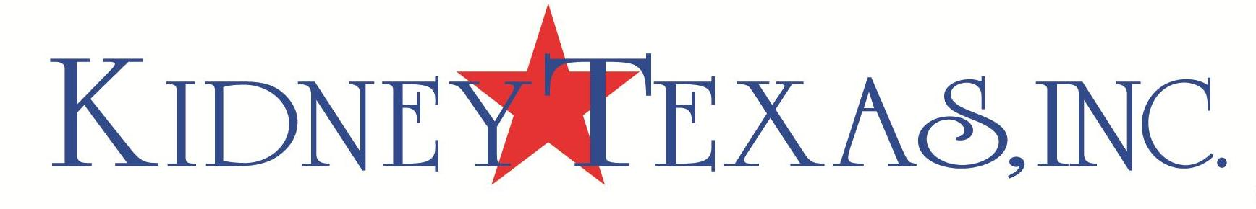

Past Luncheon Chairmen

2023 Venise Stuart
2022 Regina Bruce
Dr. Carla Russo
2021 Courtney Nall
2020 Sharon Ballew
2019 Mari Epperson
2018 Annalee Aston
Anna Bland Aston
2017 Susan Russell
Christine Martin
2016 McKamy Looney
2015 Donna Arp Weitzman
Mary Lee Cox
2014 Karen Settle
2013 Lauryn Gayle White
Terri Bumgarner
2012 Emilynn Wilson
2011 Pat McDonough
Marianne Wilshusen
2010 Carmaleta Whiteley Felton
Reneé Winter
Patty Jo Turner
2009 Teffy Jacobs
Molly Nolan
2008 Carmaleta Whiteley Felton
2007 Dyann Skelton
2006 Sharon Popham
2005 Ola Fojtasek
2004 Sharon Popham
Mary Black
2003 Fran Cashen
Reneé Winter
2002 Ann Dyer
Christine Martin
2001 Yvonne Crum
Dee Wyly
2000 Janie Donosky
Karol Wilson

