**ATTENDANCE QUESTIONNAIRE – AHS CLASS OF 1960 YORK BEACH MAINE REUNION 2024**

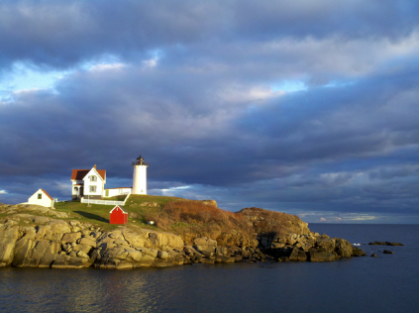

*Greetings Dear Classmate,*

*We are so excited tell you about our plans for a York Beach Maine Reunion 2024. Our reunion will take place from* ***Tuesday, September 10th, through Thursday, September 12, 2024….with a breakfast get together for those who will not be departing until Friday, September 13. (Venue TBA)***

***Staying Safe and Healthy:*** *With much thought and consideration for our classmates and their safety, we are hoping that all of our attendees have been vaccinated or will consider doing so prior to the date of our reunion.*

***Accommodations:*** *We have, once again, blocked several rooms at the Anchorage Inn, Atrium Building, 265 Long Beach Avenue, Rte. 1A, York Beach, Maine 03910. Telephone 207.363.5112. The price per night will stay the same as previous years.*

*$99 per night, plus tax, double occupancy. A special thank you to the Anchorage Inn for their continued generosity at a time when the price of everything continues to skyrocket around us!*

***Please Make Your Reservations EARLY!*** *We have been informed by the management at Anchorage Inn that there will be tour buses arriving on the same day that we are arriving so…..****please call now and make your reservations!***

***Please contact Peg Ducharme at****:* [*messagesfromtheheart@comcast.net*](mailto:messagesfromtheheart@comcast.net)*, H978.710.7373 or C617.775.1528 with any questions.*

***Mailing Address for checks payable to: Peg Ducharme****, 615 Nashua Road, Unit 21, Dracut, MA. 01826*

***Important:*** *Please fill out* ***“Attendance Questionnaire”*** *below and return it to Peg via email or to her home address* ***along with your check, by August 7, 2024.***

***Name:_______________________________________________***

***Address:_____________________________________________***

***Cell Phone:___________Home Phone:____________Email:____________________***

***Page 2.***

 ***A Little Birdie Told Us*** that there may be a couple of classmates who would love to attend our reunion but who would prefer not to drive to Maine. If you are one of those classmates, please contact *Peg Ducharme at 978.710.7373* so that we may assist you with the possibility of a solution.

***MEET & GREET PIZZA PARTY ***

***Tuesday, September 10, 5:30pm to 9pm:***

***The Anchorage Inn, Atrium Building, Lower Level Conference Room***

***265 Long Beach Avenue, York Beach, ME. 03910~Cocktails at 5:30pm***

***Cost $ 20.00 pp.***

***_____#Attending***

***\*You may send one check for all to Peg Ducharme at the address listed above by August 7. 2024.***

***Wednesday Morning Golf, September 11:***

***Cape Neddick Country Club. Time TBD***



***Please contact Steve Quattrocchi at: 781.820.5996 or*** [***saqdad@aol.com***](mailto:saqdad@aol.com) ***if you wish to golf. If your call goes to voicemail, please leave a message and Steve will call you back.***

***______#Attending***

***Page 3.***

***Wednesday Evening, September 11, Ogunquit Playhouse ~ Curtain Time ~ 8PM***

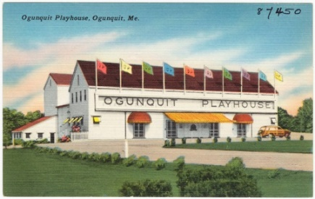

**“Little Shop of Horrors” *A Deviously Delicious Musical!***

*Meek floral assistant Seymour Krelborn stumbles across a new breed of plant he names "Audrey II" after his coworker crush. The foul-mouthed, soulful carnivore promises Seymour limitless fame and fortune, so long as he keeps feeding it HUMAN BLOOD. But as the killings increase in frequency and intensity, Seymour discovers this horticultural nightmare’s real plan is far more than he bargained for. This deviously delicious musical was born from the creative genius of Howard Ashman and Alan Menken (Disney's The Little Mermaid, Beauty and The Beast, and Aladdin) and has been devouring the hearts of theatre lovers for over 30 years.*

***Cost $ 70.00 pp Please note: Prices will increase if minimum of 20 people is not reached.***

***______#Attending***

*I have included my check for the Ogunquit Playhouse in the amount of $ _____ payable to Peg Ducharme.*

***\*Please send your check for the Ogunquit Playhouse to Peg Ducharme by***

***July 26, 2024 at the very latest.***

***Pre-Ogunquit Playhouse Restaurant Suggestion:*** *We understand that many of us will be doing various things and going in various directions during the day on Wednesday so, the team has listed below two restaurants that you may find reasonable and conveniently located to assure a timely arrival at the playhouse.*

*The Front Porch Jonathan’s*

*9 Shore Road 92 Bourne Lane*

*Ogunquit, ME. 207.646.4005 Ogunquit, ME. 207.646.4777*

[*info@thefrontportch.ogt.com*](mailto:info@thefrontportch.ogt.com)[*www.jonathansrestaurant.com*](http://www.jonathansrestaurant.com)

*Opens at 4 pm Opens at 4 pm*

***Page 4.***

***Thursday Evening, September 12, 5:30 pm:***

***“Grand Finale” Dinner!***

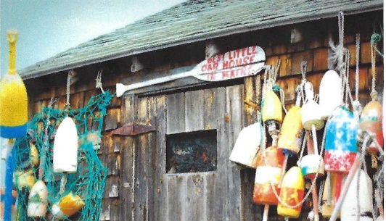

***Cape Neddick Lobster Pound***

*Visit:* [*www.capeneddicklobsterpound.com*](http://www.capeneddicklobsterpound.com) *for a complete description of each entrée*

*Choose 1:_____ Cup of Clam Chowder, or _____Demi Salad*

*Choose 1:___Chicken Marsala, or____Maine Stuffed Haddock, or ___1 1/4lb. Lobster*

*Choose 1:____Blueberry Cobbler ala mode, or____Flourless Chocolate Torte ala mode*

*Dinners include a medley of fresh vegetables, roasted potato and warm bread, Coffee and Tea.*

***Chicken Marsala or Maine Stuffed Haddock: $ 51.00 pp. includes gratuity.***

***1 1/4lb. Lobster: $62.00 pp. includes gratuity.***

***_____#Attending***

***\*Please send your check for dinner to Peg Ducharme at the address listed above by August 7, 2024.***

*Comments Welcomed_____________________________________________________________*

*We look forward to seeing you in September. Your reunion team: Peg, Nancy and Sandy!*

***Please Note: You may send one check for the total amount due if you wish. However, please be sure that it is received by Peg by August 7, 2024.***

***Thank you!***